 | NAME | LOCATION/SHIP
 | MABINE, Octavius | USS OKLAHOMA
 | MACY, Thomas Samuel, age 59 | HICKAM FIELD
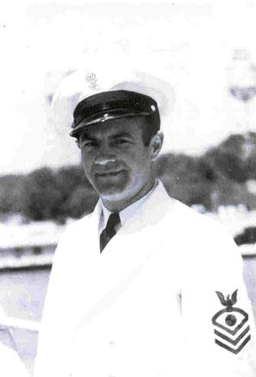 | MADDOX, Raymond “Tony” Dudley | USS ARIZONA
 | MADRID, Arthur John | USS ARIZONA
 | MAFNAS, Andres Franquez | USS NEVADA
 | MAFNAS, Francisco Reyes | USS ARIZONA
 | MAGEE, Gerald James | USS ARIZONA
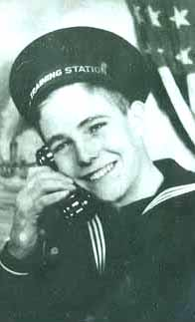 | MAGERS, Howard Scott | USS OKLAHOMA
 | MALATAK, Joseph | HICKAM FIELD
 | MALECKI, Frank Edward | USS ARIZONA
 | MALEK, Michael | USS OKLAHOMA
 | MALFANTE, Algeo Victor | USS OKLAHOMA
 | MALINOWSKI, John Stanley | USS ARIZONA
 | MALSON, Harry Lynn | USS ARIZONA
 | MANGANELLI, George Jay, age 14 | HONOLULU
 | MANGES, Howard Ellis | USS CALIFORNIA
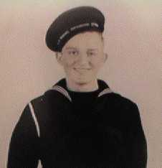 | MANION, Edward Paul | USS ARIZONA
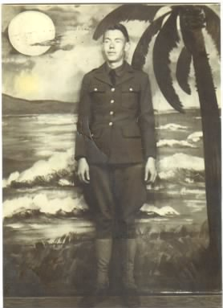 | MANLEY, William H. | WHEELER FIELD
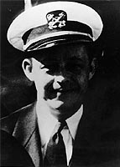 | MANLOVE, Arthur Cleon  The USS Manlove (DE-36) was named in his honor. | USS ARIZONA
 | MANN, Charles Willis | USS WEST VIRGINIA
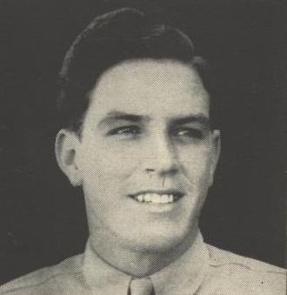 | MANN, John Henry | HICKAM FIELD
 | MANN, William Edward | USS ARIZONA
 | MANNING, Leroy | USS ARIZONA
 | MANNING, Milburn Alex  The USS Manning (DE-199) was named in his honor. | KANEOHE NAVAL AIR STATION
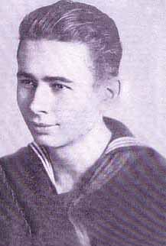 | MANNING, Walter Benjamin | USS OKLAHOMA
 | MANSKE, Robert Francis | USS ARIZONA
 | MARINICH, Steve Matt | USS ARIZONA
 | MARIS, Elwood Henry | USS ARIZONA
 | MARKLEY, Robert Harold | HICKAM FIELD
 | MARLING, Joseph Henry | USS ARIZONA
 | MARLOW, Urban Herschel | USS ARIZONA
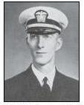 | MARSH, Benjamin Raymond Jr.  The USS Marsh (DE-699) was named in his honor. | USS ARIZONA
 | MARSH, William Arthur | USS ARIZONA
 | MARSHALL, John Andrew | USS DOWNES
 | MARSHALL, Thomas Donald | USS ARIZONA
 | MARSHALL, William Earl Jr. | USS UTAH
 | MARTIN, Dale Lewis | USS NEVADA
 | MARTIN, George M. Jr. | HICKAM FIELD
 | MARTIN, Herbert Benjamin | HICKAM FIELD
 | MARTIN, Hugh Lee | USS ARIZONA
 | MARTIN, James Albert | USS ARIZONA
 | MARTIN, James Orrwell | USS ARIZONA
 | MARTIN, John Winter | USS CALIFORNIA
 | MARTIN, Luster Lee | USS ARIZONA
 | MARTIN, Wallace R. | HICKAM FIELD
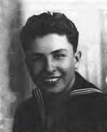 | MARTINEZ, Rudolph “Rudy” Machado | USS UTAH
 | MARZE, Andrew Michael  Killed on the Pennsylvania. | USS DOBBIN
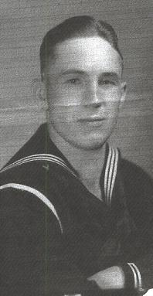 | MASON, Byron Dalley | USS ARIZONA
 | MASON, Henri Clay | USS OKLAHOMA
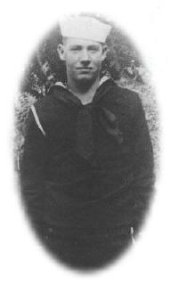 | MASSEY, James Edward | USS CURTISS
 | MASTEL, Clyde Harold | USS ARIZONA
 | MASTERS, Dayton Monroe | USS ARIZONA
 | MASTERSON, Cleburne E. Carl | USS ARIZONA
 | MASTROTOTARO, Maurice | USS CURTISS
 | MATA, Jesus Manalisay | USS WEST VIRGINIA
 | MATHEIN, Harold Richard | USS ARIZONA
 | MATHISON, Charles Harris | USS ARIZONA
 | MATHISON, Donald Joseph | USS WEST VIRGINIA
 | MATNEY, Vernon Merferd | USS ARIZONA
 | MATTOX, Harell K. | HICKAM FIELD
 | MATTOX, James Durant | USS ARIZONA
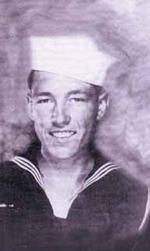 | MAULE, Joseph Keith | USS OKLAHOMA
 | MAY, Louis Eugene | USS ARIZONA
 | MAYBEE, George Frederick | USS ARIZONA
 | MAYFIELD, Frazier | USS NEVADA
 | MAYFIELD, Lester Ellsworth | USS ARIZONA
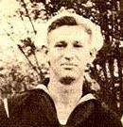 | MAYO, Marvin William | USS HELENA
 | MAYO, Rex Haywood | USS ARIZONA
 | McABEE, William E. | HICKAM FIELD
 | McALLEN, John Scott | USS SHAW
 | McBEE, Luther Kirk | USS WEST VIRGINIA
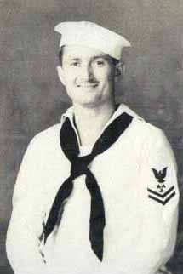 | McCABE, Edwin Bonner | USS OKLAHOMA
 | McCABE, Sr., Joseph, age 43 | HONOLULU
 | McCARRENS, James Francis | USS ARIZONA
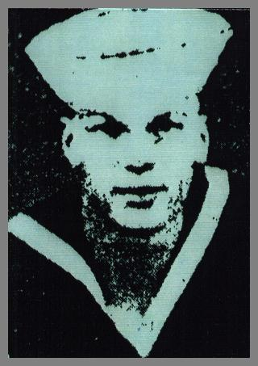 | McCARY, William Moore | USS ARIZONA
 | McCLAFFERTY, John Charles | USS ARIZONA
 | McCLELLAND, Thomas Alfred  The USS McClelland (DE-750) was named in his honor. | USS WEST VIRGINIA
 | McCLINTOCK, James Jacob | HICKAM FIELD
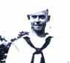 | McCLOUD, Donald Robert | USS OKLAHOMA
 | McCLUNG, Harvey Manford | USS ARIZONA
 | McCOLLOM, Lawrence Jennings | USS WEST VIRGINIA
 | McCOMAS, Clarence William | USS WEST VIRGINIA
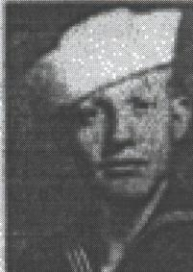 | McCUTCHEON, Warren Harrell | USS MARYLAND
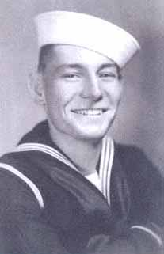 | McDONALD, James Oliver | USS OKLAHOMA
 | McFADDIN, Lawrence James | USS ARIZONA
 | McGHEE, Lester Fred | USS NEVADA
 | McGLASSON, Joe Otis | USS ARIZONA
 | McGRADY, Samme Willie Genes | USS ARIZONA
 | McGRAW, George V. | USS CALIFORNIA
 | McGUCKIN, Edward L. | USS NEVADA
 | McGUIRE, Francis Raymond | USS ARIZONA
 | McHUGHES, John Breckenridge | USS ARIZONA
 | McINTOSH, Dencil Jeoffrey | USS PENNSYLVANIA
 | McINTOSH, Harry George | USS ARIZONA
 | McKEE, Quentin Guy | USS WEST VIRGINIA
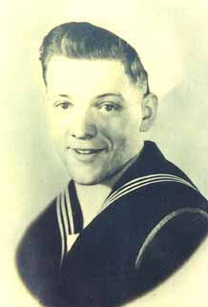 | McKEENAN, Bert Eugene | USS OKLAHOMA
 | McKINNIE, Russell | USS ARIZONA
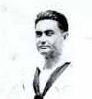 | McKISSACK, Hale | USS OKLAHOMA
 | McKOSKY, Michael Martin | USS ARIZONA
 | McLAUGHLIN, Herbert E. | HICKAM FIELD
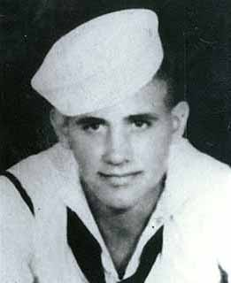 | McLAUGHLIN, Lloyd Elden | USS OKLAHOMA
 | McLEOD, Stanley A. | HICKAM FIELD
 | McMEANS, Clyde Clifton | USS CALIFORNIA
 | McMURTREY, Aaron L. | USS CALIFORNIA
 | McPHERSON, John Blair | USS ARIZONA
 | McQUADE, Robert Cameron | USS SHAW
 | MEADOWS, Durward A. | HICKAM FIELD
 | MEAGHER, Donald F. | HICKAM FIELD
 | MEANS, Louis | USS ARIZONA
 | MEARES, John Morgan | USS ARIZONA
 | MEDLEN, Joseph Alford | FT KAMEHAMEHA
 | MEGLIS, John Anthony | USS WEST VIRGINIA
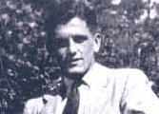 | MELTON, Earl Rudolph | USS OKLAHOMA
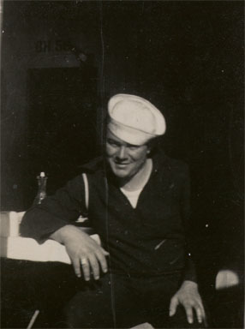 | MELTON, Herbert Franklin | USS OKLAHOMA
 | MELTON, John Russell | USS WEST VIRGINIA
 | MENDIOLA, Enrique Castro | USS WEST VIRGINIA
 | MENEFEE, James Austin | USS ARIZONA
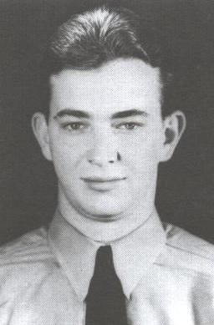 | MENGES, Herbert Hugo  Shot down by "friendly fire" in an attempt to make a night landing at Ford Island NAS.  The USS Menges (DE-320) as well as Menges Hall at the University of Louisville were named in his honor. | USS ENTERPRISE
 | MENO, Vicente Gogue | USS ARIZONA
 | MENZENSKI, Stanley Paul | USS ARIZONA
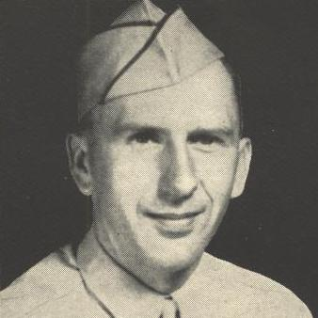 | MERITHEW, William W. | HICKAM FIELD
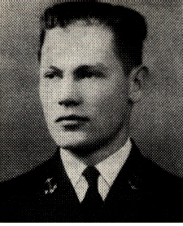 | MERRILL, Howard Deal  The USS Merrill (DE-392) was named in his honor. | USS ARIZONA
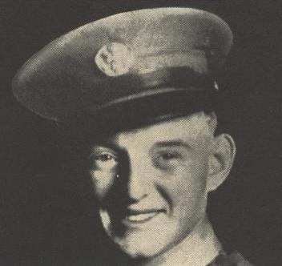 | MESSAM, Horace Arthur | HICKAM FIELD
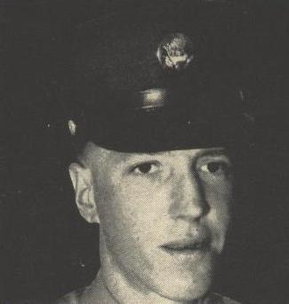 | MEYERS, Victor L. | HICKAM FIELD
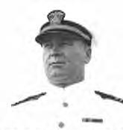 | MICHAEL, Charles O. | USS UTAH
 | MICHELETTO, Carlo Anthony | EWA MARINE CORPS AIR STATION
 | MIDDLESWART, John Franklin | USS OKLAHOMA
 | MIGITA, Torao  Killed in downtown Honolulu by "friendly fire". | SCHOFIELD BARRACKS
 | MILBOURNE, Jesse Keith | USS CURTISS
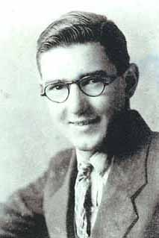 | MILES, Archie Theodore | USS OKLAHOMA
 | MILES, Oscar Wright | USS ARIZONA
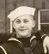 | MILLER, Chester John | USS ARIZONA
 | MILLER, Doyle Allen | USS ARIZONA
 | MILLER, Forrest Newton | USS ARIZONA
 | MILLER, George Stanley | USS ARIZONA
 | MILLER, J.B. Delane | USS TENNESSEE
 | MILLER, Jessie Zimmer | USS ARIZONA
 | MILLER, John David | USS ARIZONA
 | MILLER, Marvin Eugene | USS UTAH
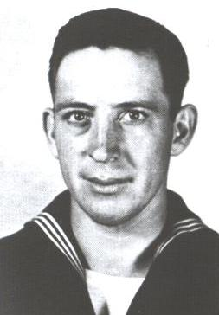 | MILLER, William Cicero  Arrived over Oahu during the attack and was shot down by the Japanese.  The USS William C. Miller (DE-259) was named in his honor. | USS ENTERPRISE
 | MILLER, William Oscar | USS ARIZONA
 | MILLIGAN, Weldon Hawvey | USS ARIZONA
 | MILNER, James William | USS CALIFORNIA
 | MIMS, Robert Lang | USS ARIZONA
 | MINEAR, Richard J. Jr. | USS ARIZONA
 | MINIX, Orville Ray | USS HELENA
 | MINTER, James Dewey | USS CALIFORNIA
 | MIRELLO, Bernard Joseph | USS CALIFORNIA
 | MISTER, Joe Eddie | USS WEST VIRGINIA
 | MITCHELL, Edwin N. | HICKAM FIELD
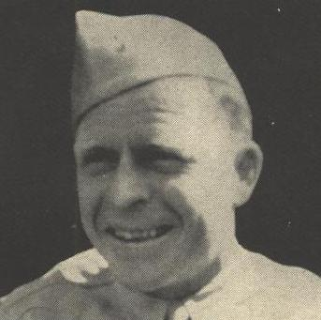 | MITCHELL, John G. | WHEELER FIELD
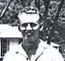 | MITCHELL, Wallace Gregory | USS OKLAHOMA
 | MLINAR, Joseph | USS ARIZONA
 | MOLPUS, Richard Preston | USS ARIZONA
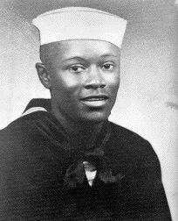 | MONROE, Donald | USS ARIZONA
 | MONTGOMERY, Charles Andrew | USS OKLAHOMA
 | MONTGOMERY, Robert E. | USS ARIZONA
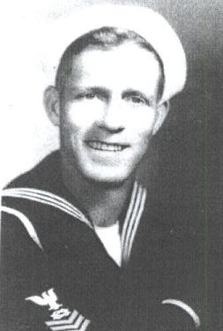 | MONTGOMERY, Wallace Alford | USS WEST VIRGINIA
 | MONTGOMERY, William A. | USS CALIFORNIA
 | MOODY, Robert Edward | USS ARIZONA
 | MOORE, Clyde Carson | USS SHAW
 | MOORE, Douglas Carlton | USS ARIZONA
 | MOORE, Fred Kenneth  The USS Moore (DE-240) was named in his honor.  Was posthumously awarded the Navy Cross. | USS ARIZONA
 | MOORE, James Carlton | USS ARIZONA
 | MOORHEAD, Lionel Jay | HICKAM FIELD
 | MOORMAN, Russell Lee | USS ARIZONA
 | MORAN, George A. | HICKAM FIELD
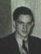 | MOREHOUSE, William Starks | USS ARIZONA
 | MORGAN, Wayne | USS ARIZONA
 | MORGAREIDGE, James Orries | USS ARIZONA
 | MORINCELLI, Edo | USS HELENA
 | MORLEY, Eugene Elvis | USS ARIZONA
 | MORRELL, Elmer R. | MIDWAY ISLAND NAVAL AIR STATION
 | MORRIS, Emmett Edloe | HICKAM FIELD
 | MORRIS, Owen Newton | USS ARIZONA
 | MORRIS, William Francis | USS WEST VIRGINIA
 | MORRISON, Earl Leroy | USS ARIZONA
 | MORRISSEY, Edward Francis | USS NEVADA
 | MORSE, Edward Charles | USS ARIZONA
 | MORSE, Francis Jerome | USS ARIZONA
 | MORSE, George Robert | USS ARIZONA
 | MORSE, Norman Roi | USS ARIZONA
 | MOSER, Joseph G. | HICKAM FIELD
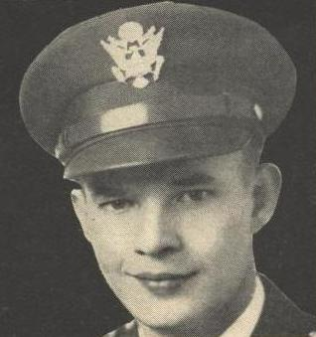 | MOSLENER, Louis Gustav Jr.  Was originally attached to the 44th Bomb Group and arrived in Hawaii two days prior to the attack to outfit his plane for a secret Photo mission. He was killed on the ground and his B-24 was destroyed near Hangar 15. | HICKAM FIELD
 | MOSS, Tommy Lee | USS ARIZONA
 | MOSTEK, Francis Clayton | USS ARIZONA
 | MOULTON, Gordon Eddy | USS ARIZONA
 | MRACE, Albin John | USS WEST VIRGINIA
 | MUHOFSKI, Joseph Alexander | USS PENNSYLVANIA
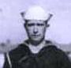 | MULICK, John Mark | USS OKLAHOMA
 | MUNCY, Claude | USS ARIZONA
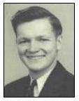 | MURDOCK, Charles Luther | USS ARIZONA
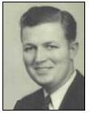 | MURDOCK, Melvin Elijah | USS ARIZONA
 | MURPHY, James Joseph | USS ARIZONA
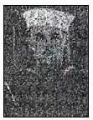 | MURPHY, James Palmer | USS ARIZONA
 | MURPHY, Jessie Huell | USS ARIZONA
 | MURPHY, Thomas, J. Jr. | USS ARIZONA
 | MYERS, Clair Clifton | USS WEST VIRGINIA
 | MYERS, James Gernie | USS ARIZONA
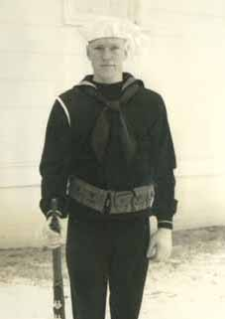 | MYERS, Ray Harrison | USS OKLAHOMA

